**5.2 Factors Affecting Resistance** Name: __________________________

Score: _______ / 25

**Purpose:** To measure and evaluate three factors determining the resistance of a resistor, resistivity of the resistor material, the length of the resistor, and the cross-sectional area of the resistor. Temperature dependence is not covered in this lab, although temperature changes will change the resistivity of most materials.

**Background:** Resistance depends on a number of factors. The first is the resistivity of the material itself. Some materials are naturally very good conductors with low resistivity ( ), such as copper, silver and gold. Others are very poor conductors with high resistivity, such as glass and rubber. Good conductors have resistivities approaching zero, while insulators have resistivities approaching infinity. The second factor is length ( **L** ). Resistance is directly proportional to the length of the material. The third is the cross sectional area ( **Ax** ) of the material. A narrow wire forces the charges closer together and their mutual repulsion increases the resistance. Resistance is inversely proportional to the cross-sectional area; the larger the area the smaller the resistance.

In this experiment, you will investigate the relationships among these factors: resistivity of the material ( ), its length ( **L** ), and its cross-sectional area ( **Ax** ). These three are related according to the equation

$R=ρ \frac{L}{A}$ ( Equation 1)

There will be 1.00 m lengths of wire taped down to a meter stick serving as our wire samples. The resistance of the wire will be measured by placing the wire in a circuit and recording the current and potential for the circuit. The resistance can then be calculated from Ohm’s Law (**V = IR).** To see the effect of cross sectional area ( **Ax** ) we will test the resistance of 3 different gauge wires: 22 gauge (0.64516 mm diameter) 24 gauge (0.51054 mm diameter) or 26 gauge (0.40386 mm diameter) all made out of Nichrome metal ( = 1.50 x 10-6  Ωm). We will also have 24 gauge Copper ( = 1.72 x 10-8  Ωm) and 24 gauge Steel ( = 4.60 x 10-7 Ωm) to be able to see the dependence of resistance on resistivity. Lastly, using the 24 gauge Nichrome wire, we can test the dependence of resistance on length by connecting the circuit at different points along the meter stick.

**Prelab:**  Use the space below to derive the derived units of resistivity, ( ) usually written as Ωm. Express the result in fundamental units only (kg, m, s, C, only). Recall, V = IR, Volt = Joule/Coulomb, and Ampere = Coulombs/second. Finally, remember that a Joule = Newton-meter and a Newton, is defined from F = ma.

Derivation of the units of Resistivity:

**Materials:**

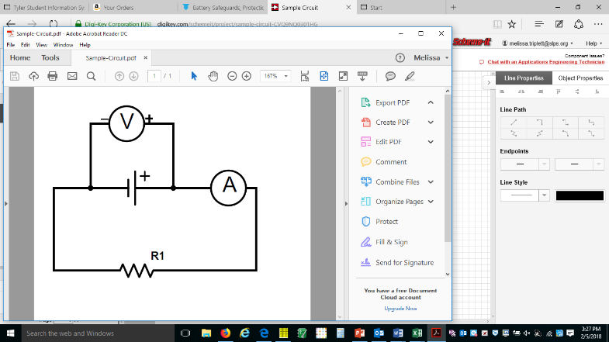1.00 m wires taped to meter sticks (22, 24, 26 gauge Nichrome or 24 gauge Copper or 24 gauge Steel)

Multimeter to measure current

Vernier Sensor (or second multimeter) to measure voltage

D Battery power pack

Alligator clip wires to complete circuit:

**Procedure:**

Circuit construction: Connect the parts of a circuit in the following manner.

Multi-meter (V)

Or Vernier (V)

D Battery

Meter stick and wire

A

B

Multi-meter (10A)

Or Vernier (A)

x

0 cm

100 cm

If the voltage reading is negative, switch wires A and B. When you need to use a shorter length, move the clip of wire x from the 100 cm mark to a different cm mark on the meter stick. Record the voltage and current reading for each circuit.

**SAFETY NOTICE: NEVER TOUCH A BARE WIRE OR METAL IN A COMPLETED CIRCUIT. MAKE OR BREAK CIRCUIT AT A PLASTIC COVERED PLACE.**

**Data and Calculations**

**Part 1: Cross sectional area dependence**

For each of the three wires listed complete the circuit with the clips at the furthest possible end of the 1.00 m wires. Measure the voltage and the current. Calculate the resistance using Ohm’s Law.

|  |  |  |  |  |
| --- | --- | --- | --- | --- |
| **Wire ID** | **Voltage (V)** | **Current (A)** | **Resistance (Ω)** | **Cross Sec. Area** |
| **NiCr 22** |  |  |  |  |
| **NiCr 24** |  |  |  |  |
| **NiCr 26** |  |  |  |  |

**Show the work for the calculations of Cross sectional Area:**

**Demonstrate whether the cross sectional area dependence is zero (R is constant), directly proportional (R/A is constant) or inversely proportional (RA is constant). Then state the cross sectional dependence.**

**Part 2: Metal resistivity dependence**

Copy the NiCr 24 voltage and current data from Part 1 for the 1.00 m reading. Measure the voltage and current when you connect the circuit at each of the following points on the meter stick. Calculate the resistance using Ohm’s Law.

|  |  |  |  |
| --- | --- | --- | --- |
| **Length NiCr24** | **Voltage (V)** | **Current (A)** | **Resistance (Ω)** |
| **1.00 m** |  |  |  |
| **0.90 m** |  |  |  |
| **0.80 m** |  |  |  |
| **0.70 m** |  |  |  |
| **0.60 m** |  |  |  |
| **0.50 m** |  |  |  |
| **0.40 m** |  |  |  |
| **0.30 m** |  |  |  |

**On the graph provided plot R vs L. Based on your graph determine whether the length dependence is zero, direct or inverse: ____________________________**



**Part 3: Metal resistivity dependence**

Copy the NiCr 24 voltage and current data from Part 1. Record the resistivities from the background information.

Measure the voltage and current for the Copper wire and the Steel wire. Calculate the resistance using Ohm’s Law.

|  |  |  |  |  |
| --- | --- | --- | --- | --- |
| **Wire ID** | **Voltage (V)** | **Current (A)** | **Resistance (Ω)** | **Resistivity** |
| **NiCr 24** |  |  |  |  |
| **Cu 24** |  |  |  |  |
| **Steel 24** |  |  |  |  |

**Demonstrate whether the resistivity dependence is zero (R is constant), directly proportional (R/ is constant) or inversely proportional (R is constant). Then state the resistivity dependence.**

**Questions:**

1. The National Institute of Occupational Safety and Health states "Under dry conditions, the resistance offered by the human body may be as high as **100,000 Ohms**. Wet or broken skin may drop the body's resistance to **1,000 Ohms**," Complete the table below to determine the danger levels of voltage with dry skin and with wet skin.

|  |  |  |  |
| --- | --- | --- | --- |
| **Sensation** | **Current** | **Required Dry V** | **Required Wet V** |
| **Threshold of Sensation** | **0.002 A** |  |  |
| **Mild Tingling** | **0.008 A** |  |  |
| **Painful Shock** | **0.02 A** |  |  |
| **Muscle Paralysis** | **0.04 A** |  |  |
| **Severe Shock** | **0.05 A** |  |  |
| **Breathing Upset** | **0.07 A** |  |  |
| **Extreme Breathing Difficulty** | **0.08 A** |  |  |
| **Death** | **0.10 A** |  |  |

2. Why do you think most commercial wiring is made out of copper? Why not steel?

3. Do your results support the equation 1 for the calculation of resistance? Why or why not? Use examples from your data to support your answer.

4. What sources of error are present for the circuit used to perform this experiment? State at least 2 and identify each as a systematic or random error.